April James

[jamesap@oregonstate.edu](mailto:jamesap@oregonstate.edu)

**Project #4: Strange Dining Table With Good Lighting**

The fourth CS450 graphics assignment deals with lighting and material characteristics. The objectives included:

* Creating at least one point light and spot light, and white and colored lights
* Playing with stationary and in-motion lighting
* Modifying material characteristics to accommodate for responsiveness to lighting, such as color and shininess
* Experimenting with smooth and flat shading

Here are screenshots of my strange scene in all its glory:

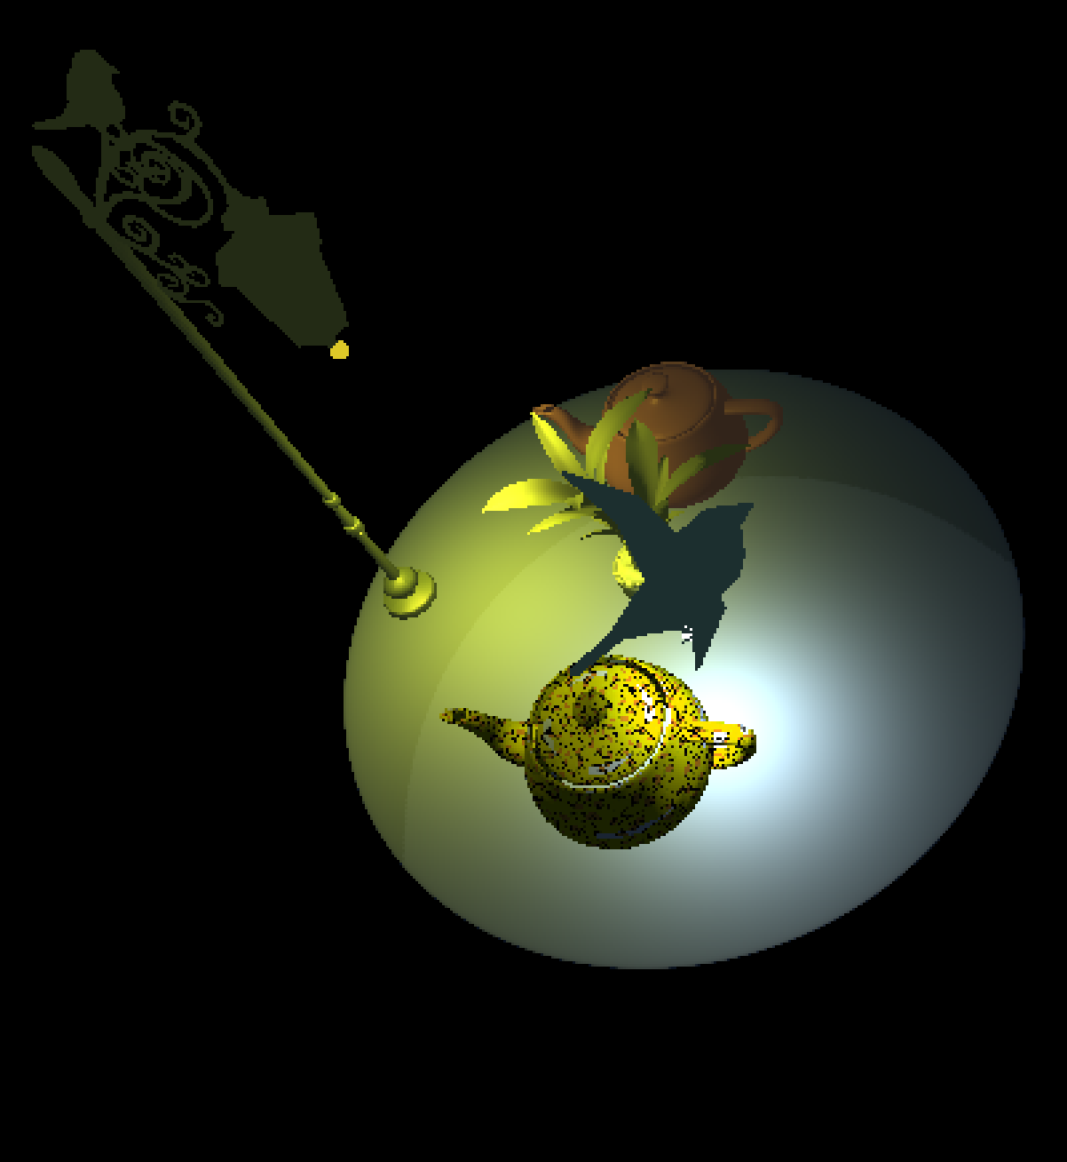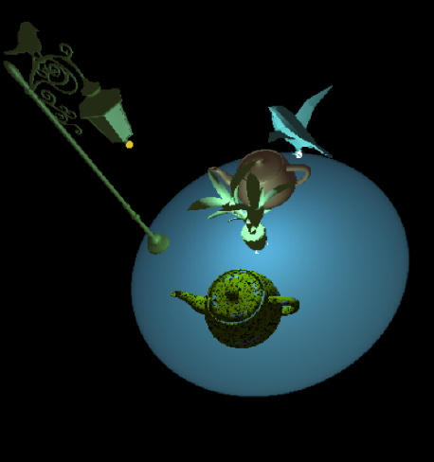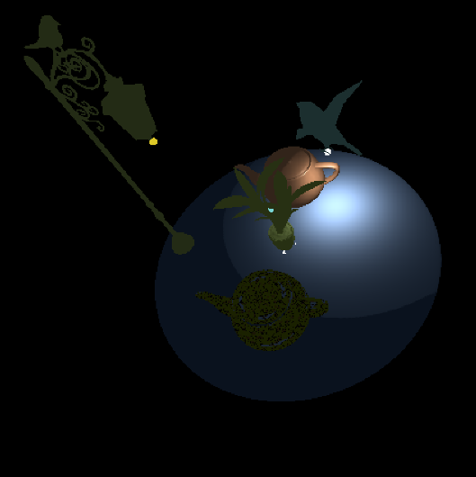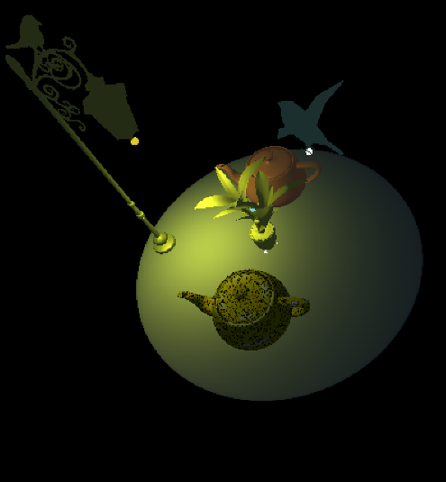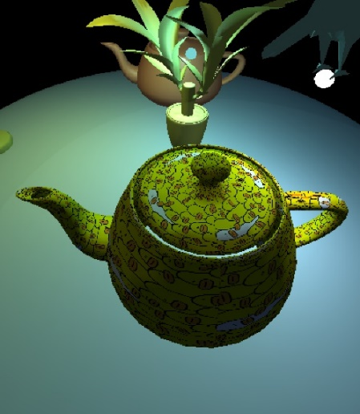

Figure 2: Light One On

Figure 1: Light Zero On

Figure 4: Light Zero in Motion!

Figure 5: Texture and Lighting in Action

Figure 3: Light Two On

Here is a link to the project video: <https://youtu.be/i9709VPeB4A>

Thank you!